**Process**

**The process** is a running program

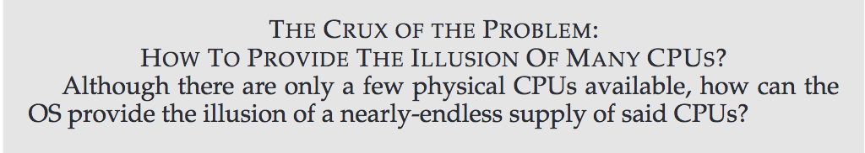

The OS creates this illusion by virtualizing the CPU.

Time sharing : run one process, stop it, Run another process.

Allows users to run as many concurrent processes as they would like; as each will run more slowly if the CPU(s) must be shared

To implement virtualization of the CPU, and to implement it well, theOS will need both some low-level machinery and some high-level intelligence. We call the low-level machinery mechanisms

**Context sWitch** : which gives the OS the ability to stop running one program and

start running another on a given CPU

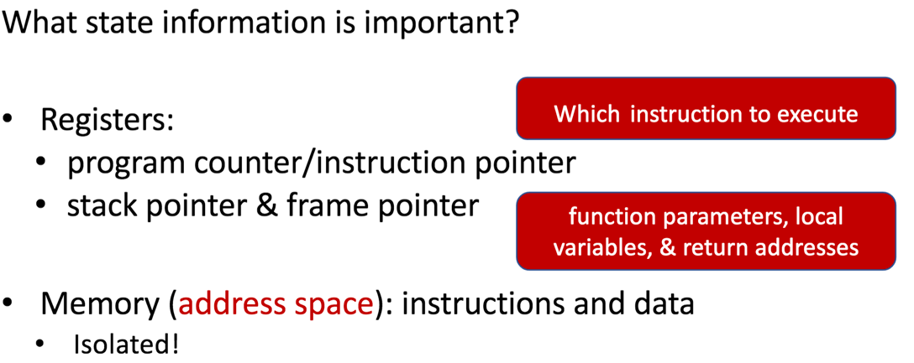

Process Creation

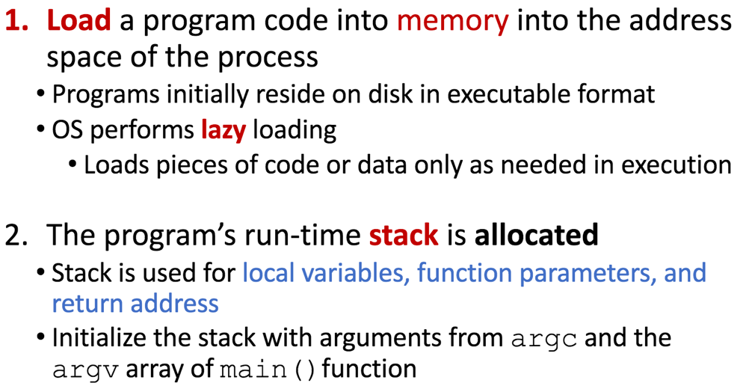

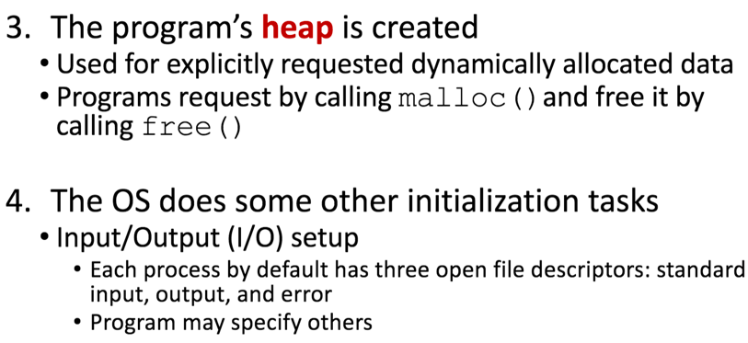

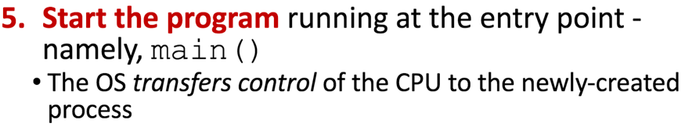

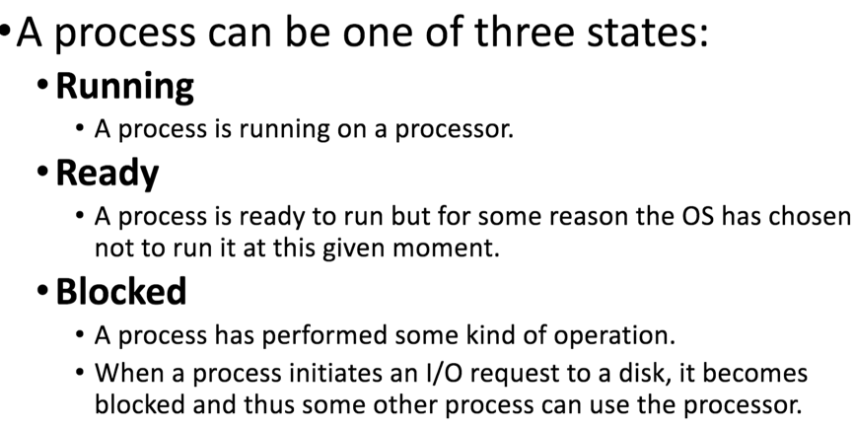

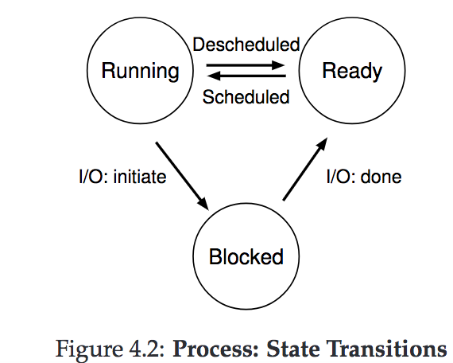Being moved from ready to running means the process has been

sched-uled; being moved from running to ready means the process has been descheduled

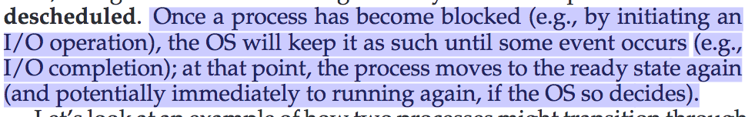

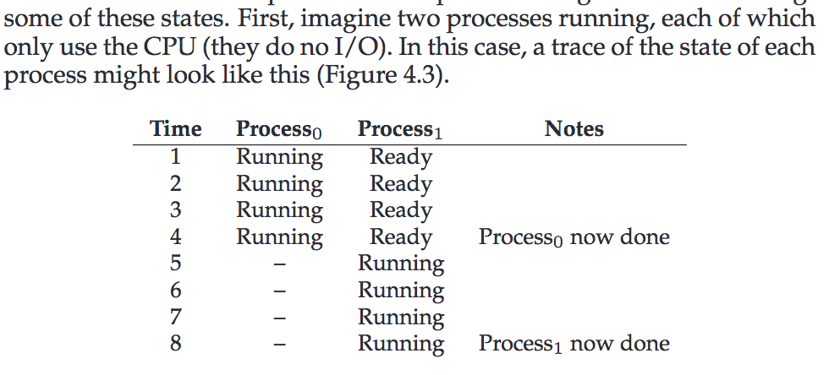

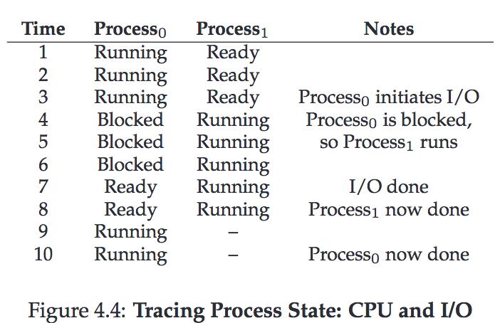

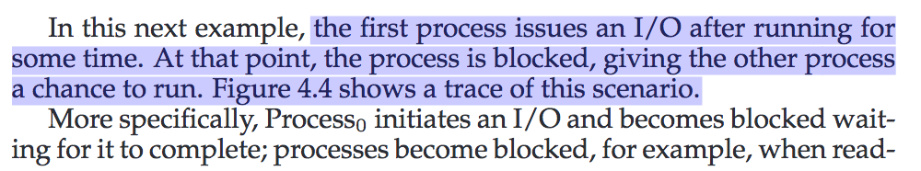

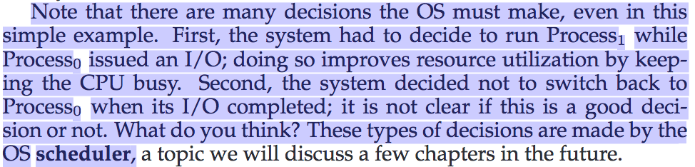

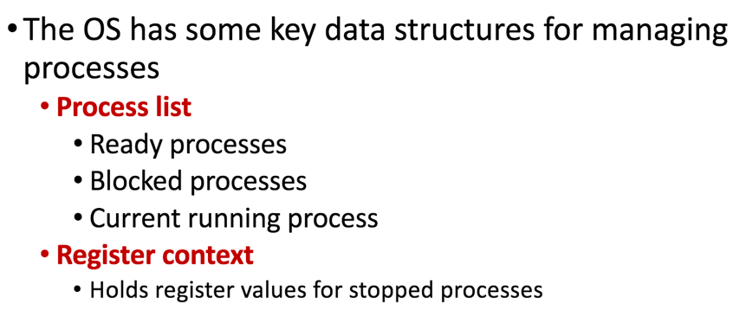

A process list contains information about all processes in the system.

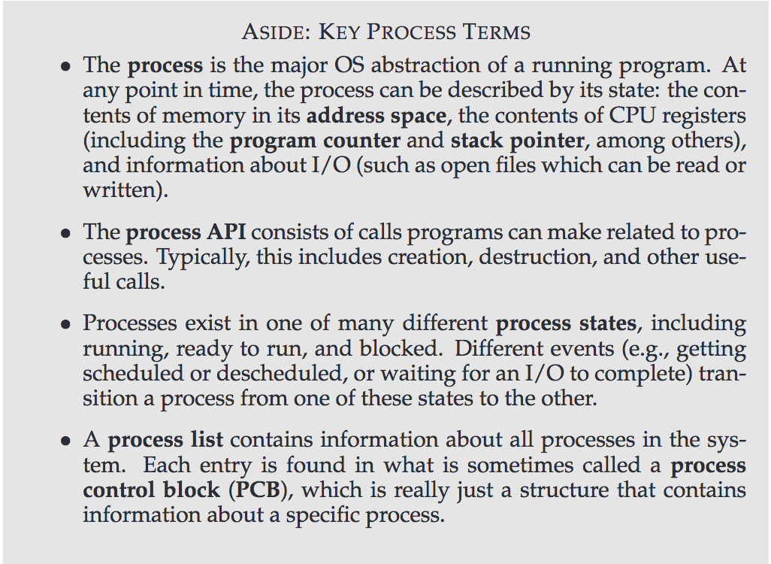

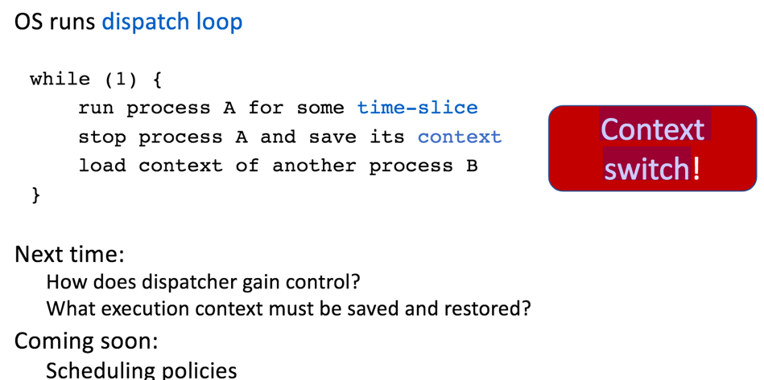

**Process API**

-Consist of call program can make related to process

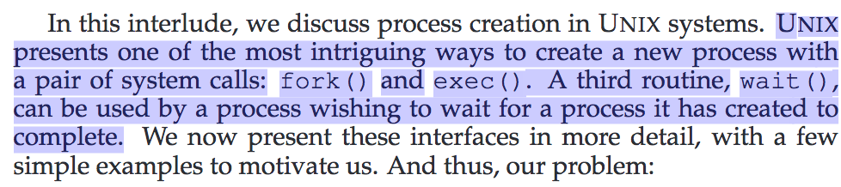

The fork()system call is used to create a new process

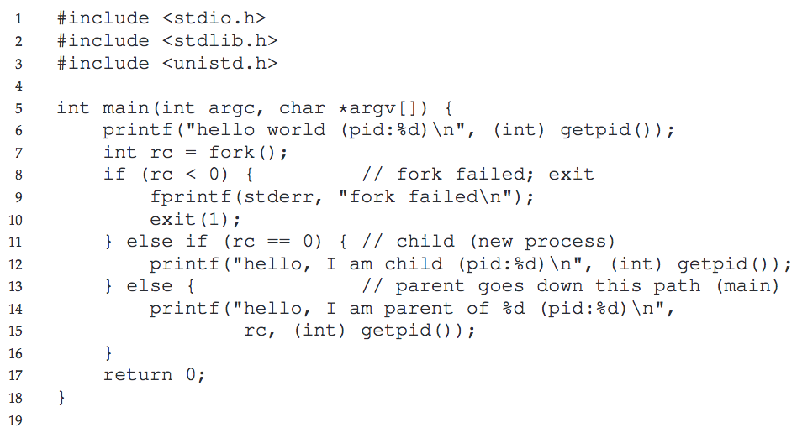

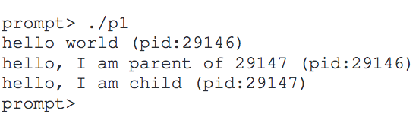

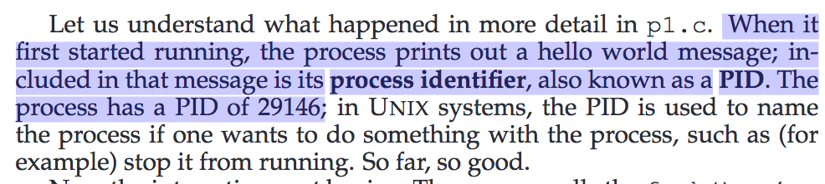

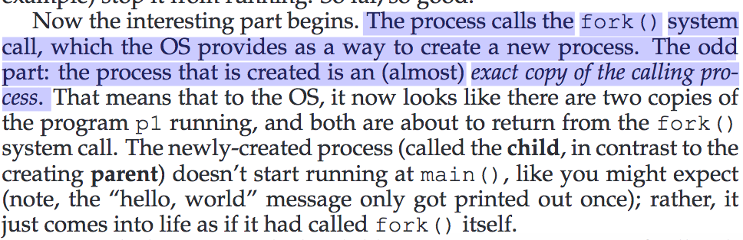

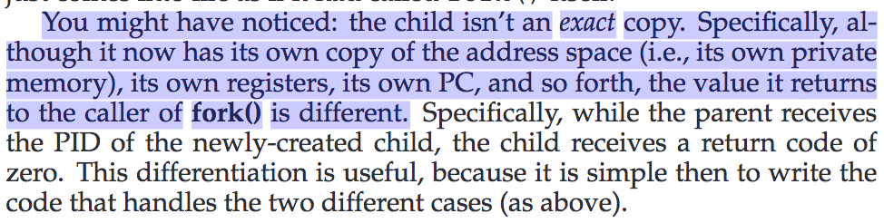

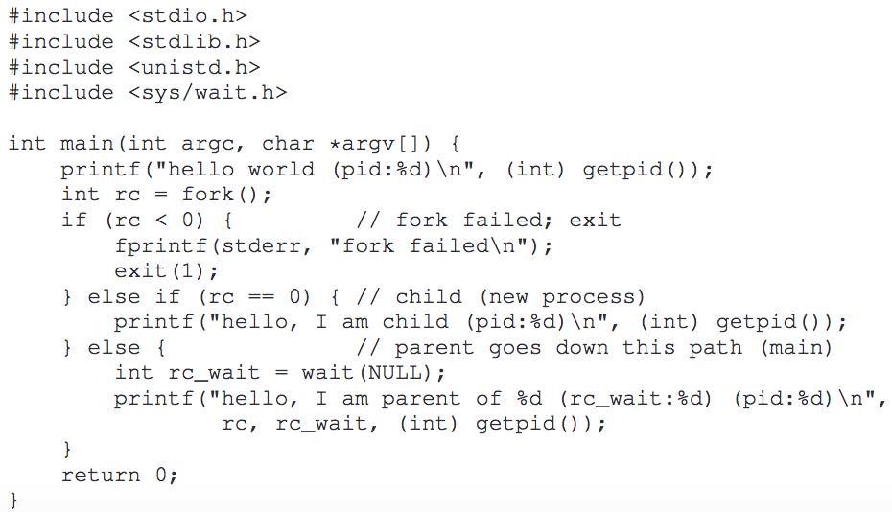

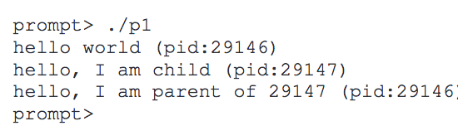

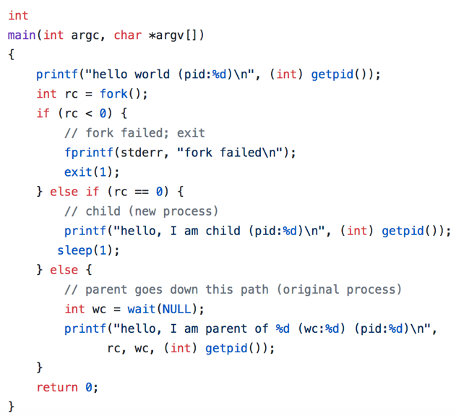

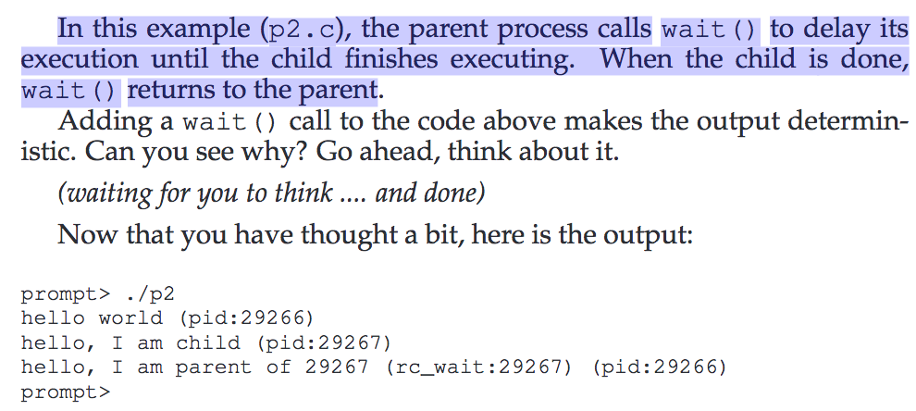

The wait() system call allows a parent to wait for its child to com-

plete execution.

The exec() family of system calls allows a child to break free from

its similarity to its parent and execute an entirely new program

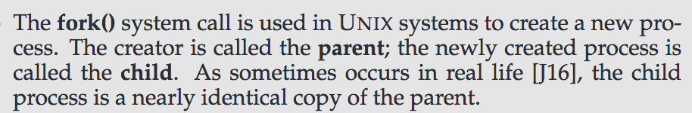

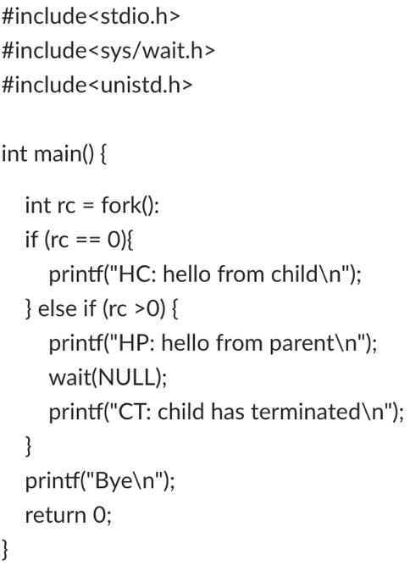

**There are two possible outputs for this program.**

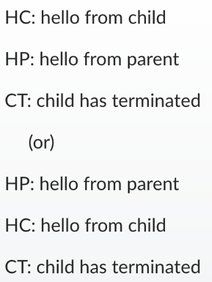

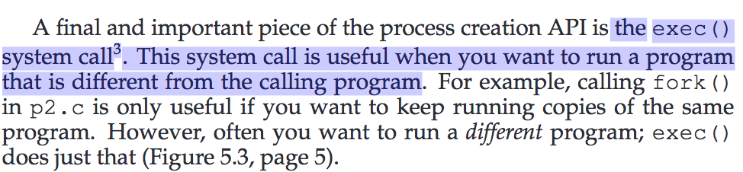

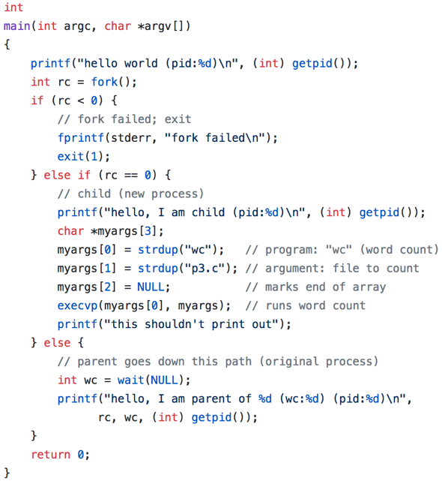

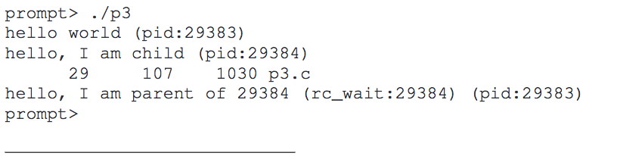

**What are the two main functions of an operating system**

-An operating system must provide the users with an extended (i.e., virtual) machine,and it must manage the I/O devices and other system resources.

**What is multiprogramming**

Multiprogramming is the rapid switching of the CPU between multiple processes in

memory. It is commonly used to keep the CPU busy while one or more processes are doing I/O.

What is the difference between timesharing and multiprogramming

Systems

-In a timesharing system, multiple users can access and perform computations on a

computing system simultaneously using their own terminal

-Multiprogramming systems

allow a user to run multiple programs simultaneously

What is spooling? Do you think that advanced personal computers will have spooling as a standard feature in the future

-Input spooling is the technique of reading in jobs, for example, from cards, onto the

disk, so that when the currently executing processes are finishe. Output spooling consists of first copying printable files to disk

before printing them, rather than printing directly as the output is generated

There are several design goals in building an operating system, for example, resource utilization, timeliness, robustness, etc. Give an example of two design goals that may contradict one another.

Consider the goals of fairness and real time. Fairness requires that each

process be allocated its resources in a fair way, with no process getting more than its fair share

Onthe other hand, real time requires that resources be allocated based on the times when different process must complete their execution. A high priority

real-time process may get a disproportionate share of the resources.

